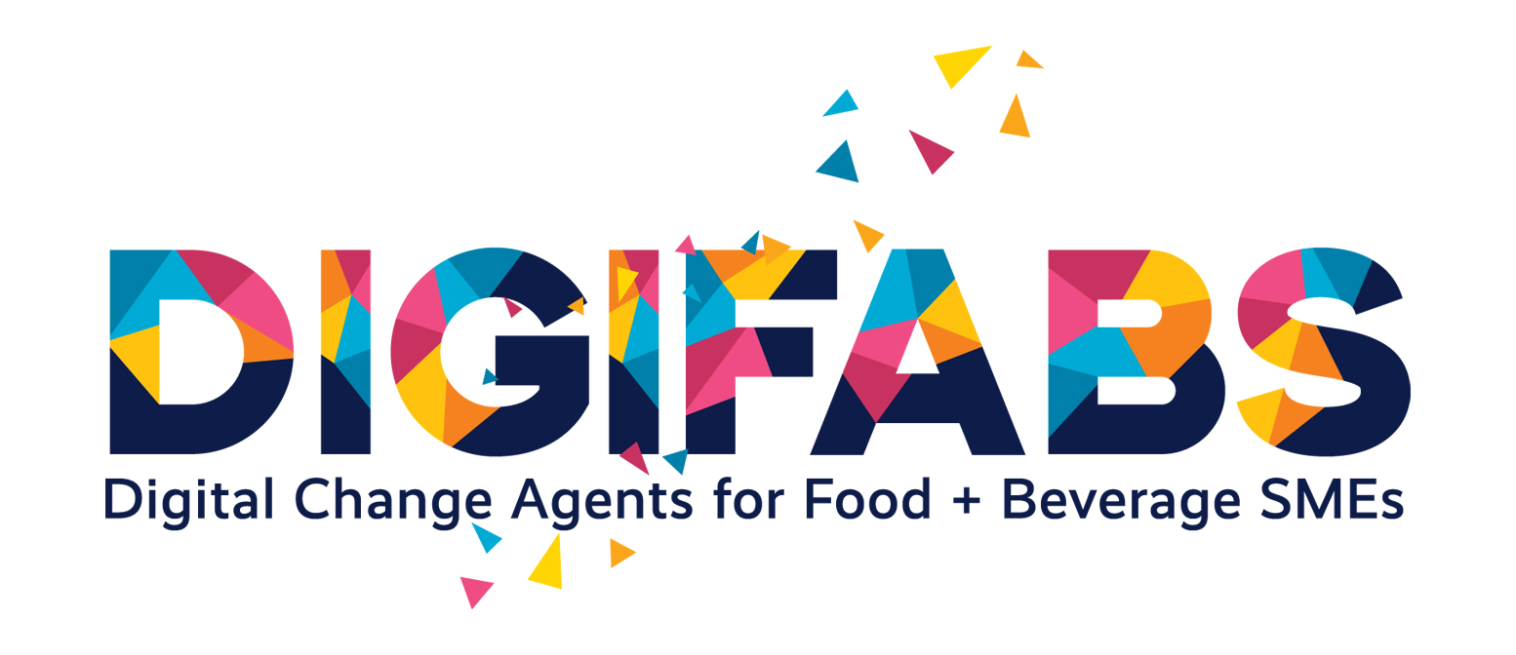ADDITIONAL RESOURCE 2 | Challenges of F&B Sector

3_2 MATRIX: Barriers vs Enablers for Digital Transformation
Module: Challenges of F&B Sector
Purpose of the Resource | This matrix helps learners identify why digital transformation can be difficult for F&B SMEs and what practical conditions can support successful adoption. It directly expands the module section on the risks of going digital.
Target User | Students; SME representatives; educators; facilitators; RDDCA trainees.
How to Use | Use after PART 3, after the presentation on digital responses and barriers for F&B SMEs. Learners should complete the matrix for a specific SME or challenge case.
Estimated Time | 20–30 minutes

Matrix
Barrier | Why it matters for the SME | Possible enabler | First practical action
Lack of digital skills |  | Training, mentoring, simple tools, external support
High upfront investment |  | Low-cost pilot, phased implementation, funding support
Resistance to change |  | Staff involvement, clear benefits, internal communication
Data trust and security concerns |  | Transparent data rules, GDPR compliance, cybersecurity basics
Unclear return on investment |  | Define measurable benefit, start with small pilot
Lack of time |  | Short testing cycles, simple templates, facilitator support
Poor data quality |  | Improve data collection, define what data are needed
Technology not matched to real need |  | Problem-first analysis, avoid technology-first decisions

ADDITIONAL RESOURCE 2 | Challenges of F&B Sector

Barriers vs Enablers Matrix for Digital Transformation
Reflection and Prioritisation
Reflection Questions
Question | Learner notes
1. Which barrier is the most serious for the selected SME?
2. Which barrier can be addressed first with limited resources?
3. What would make digital change harder in this SME?
4. What would help the SME gain trust in the solution?
5. What should an RDDCA do before recommending a digital tool?
Final Prioritisation
Top barrier: | ________________________________________________________________________________
Most realistic enabler: | ________________________________________________________________________________
First action within 7 days: | ________________________________________________________________________________
Support needed from educator / facilitator / SME mentor: | ________________________________________________________________________________

