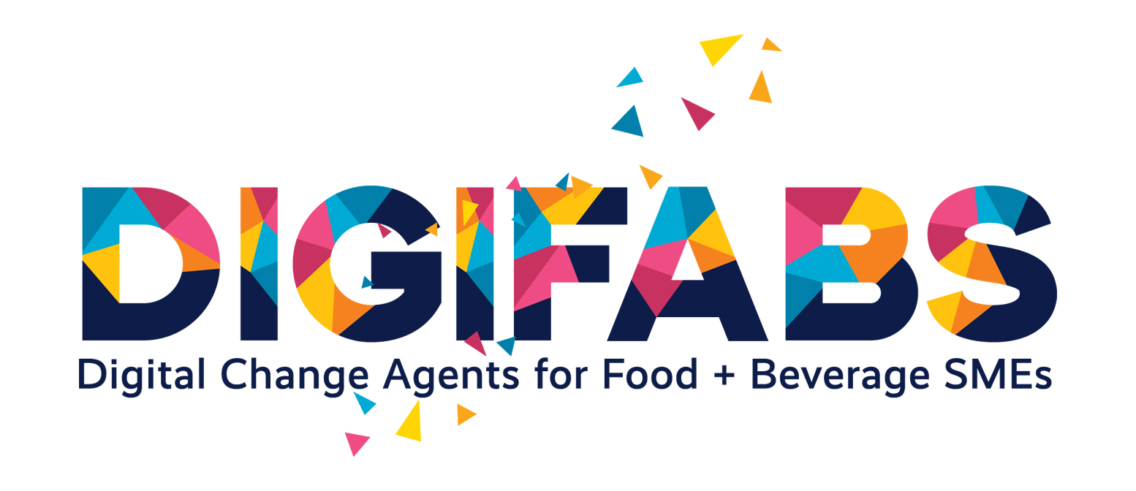ADDITIONAL RESOURCE 3 | Challenges of F&B Sector

4_2 TEMPLATE: Blockchain Traceability Use Case
Module: Challenges of F&B Sector | OPTIONAL / ADVANCED TRACK
Purpose of the Resource | This template helps learners assess whether blockchain or another traceability solution is relevant for a specific F&B SME challenge. It prevents technology-first thinking and encourages learners to start from the business problem, available data, value chain actors and feasibility conditions.
Target User | Students; educators; SME representatives; facilitators; learners working with traceability, transparency or compliance challenges.
How to Use | Use after PART 4, after the blockchain and traceability section. It can also be used as an optional advanced activity for learners with interest in digital technologies, supply chains or data systems.
Estimated Time | 45–60 minutes

1. Use Case Title
Use case title: | Example: Traceability for local dairy products / Sustainable sourcing verification / Food recall support / Ingredient origin transparency.  ________________________________________________________________________________
2. SME and Product Context
SME name or case: | ________________________________________________________________________________
Product category: | ________________________________________________________________________________
Supply chain actors involved: | ________________________________________________________________________________
Main traceability problem: | ________________________________________________________________________________

ADDITIONAL RESOURCE 3 | Challenges of F&B Sector

Blockchain Traceability Use Case Template
Problem first and data needed
3. Problem First
• ☐ Lack of transparency
• ☐ Food safety risk
• ☐ Slow recall process
• ☐ Weak sustainability claim verification
• ☐ Consumer trust issue
• ☐ Regulatory compliance issue
• ☐ Data fragmentation
• ☐ Other:
Explain the problem: | ________________________________________________________________________________
4. Data Needed
• ☐ Product origin
• ☐ Batch number
• ☐ Supplier information
• ☐ Processing step
• ☐ Certification
• ☐ Temperature / storage condition
• ☐ Transport information
• ☐ Sustainability data
• ☐ Quality control data
• ☐ Other:

ADDITIONAL RESOURCE 3 | Challenges of F&B Sector

Blockchain Traceability Use Case Template
Stakeholders
5. Stakeholders
Stakeholder | Role in the traceability system
Farmer / supplier
Processor
Distributor
Retailer
Customer
Certification body
Regulator
Other

ADDITIONAL RESOURCE 3 | Challenges of F&B Sector

Blockchain Traceability Use Case Template
Is blockchain necessary?
6. Is Blockchain Necessary?
Question | YES / NO / UNCLEAR
Are multiple actors involved?
Is trust between actors limited?
Is data immutability important?
Does the SME need verifiable traceability?
Would a simpler database be enough?
Are the costs realistic for the SME?
Is there capacity to maintain the system?

ADDITIONAL RESOURCE 3 | Challenges of F&B Sector

Blockchain Traceability Use Case Template
Benefits, risks and recommendation
7. Possible Benefits
• ☐ Faster recall management
• ☐ Greater consumer trust
• ☐ Better sustainability claim verification
• ☐ Improved compliance
• ☐ Better supplier transparency
• ☐ Reduced data disputes
• ☐ Other:
Explain the expected benefit: | ________________________________________________________________________________
8. Risks and Limitations
• ☐ High cost
• ☐ Technical complexity
• ☐ Poor data quality
• ☐ Lack of stakeholder participation
• ☐ Data privacy issue
• ☐ Overpromising transparency
• ☐ Not necessary for the problem
• ☐ Other:
Explain the main risk: | ________________________________________________________________________________

ADDITIONAL RESOURCE 3 | Challenges of F&B Sector

Blockchain Traceability Use Case Template
Recommendation
9. Recommendation
Should the SME use blockchain for this challenge?
• ☐ Yes
• ☐ Yes, but only as part of a broader traceability system
• ☐ Not yet - data and processes must be improved first
• ☐ No - a simpler digital tool is more suitable
Justification: | ________________________________________________________________________________  ________________________________________________________________________________

